Final Year Project

**Hostel Allotment System**



Submitted By

Tariq Khan 17-SE-105

M Zafeer Kamran Abid 17-SE-81

Haroon Malik 17-SE-37

Supervisor

Dr. Mubashir Ayub

Assistant Professor

DEPARTMENT OF SOFTWARE ENGINEERING

FACULTY OF TELECOMMUNICATION AND INFORMATION

ENGINEERING

UNIVERSITY OF ENGINEERING AND TECHNOLOGY

TAXILA

November 2021

# Abstract

Hostel Allotment System

This system is designed for the hostel allotment process that will increase the speed of allotment process and reduce the effort of all the users of the system. Students also take benefits from this system as it will minimize effort by filling the form online in a short time and they do not need to have a physical appearance like before. This system will allot the rooms with just one click after defining the policies about hostels.

# UNDERTAKING

We certify that the project work titled “*Hostel allotment system*” is my own work. The work has not been presented elsewhere for assessment. Where material has been used from other sources it has been properly acknowledged/referred.

M. Zafeer Kamran Abid (17-SE-81)

Sign: **Zafeer**

Haroon Malik (17-SE-37)

Sign: **Haroon**

Tariq Khan (17-SE105)

Sign: **Tariq**

# ACKNOWLEDGMENT

We would like to thank Allah Almighty for granting me the ability and a chance to complete and present this research work. I owe my gratefulness for my Supervisor Dr. Mubashir Ayub for providing me with a supporting and friendly environment throughout the work. It was a great experience to carry out my research work under his supervision. He encouraged me in every moment when I was losing hope and made me identify my abilities. He was always reachable for me with the utmost dedication for discussion in a very friendly environment throughout this research work.

We owe the greatest debt to my parents, my brothers, and sisters for their constant support, not in this project but in all other aspects of my life.

Last, but not least; We would like to express my sincere appreciation to my friends and colleagues for their love and support throughout this research work*.*

***TO MY RESPECTED TEACHERS, PARENTS, BROTHER, SISTERS, AND FRIENDS.***

Table of Contents

Abstract 2

UNDERTAKING 3

ACKNOWLEDGMENT 4

LIST OF FIGURES 7

Chapter 1 9

Introduction 9

I.1 Problem Statement 9

I.2 Project Goal 9

I.3 Aims and Objectives. 10

1.4. Deliverables 10

Chapter 2 11

Literature Review 11

2.1. Literature Survey 11

2.1.1. Drawbacks of existing system 12

2.2. Market Survey 12

2.3. College Hostel Management Software by Initio 13

2.4. IIUI Hostel 14

2.5. City Hostels 16

Chapter 3 19

Methodology 19

3.1. Methodology 20

3.1.1. Development Steps 20

3.2. How it works? 21

3.3. Development tools 21

3.3.1. React [8] 22

3.3.2. Node.JS [9] [10] 23

3.3.3. MongoDB [11] 24

3.4. Block-Diagram 25

3.5. Use-case diagram 25

3.6. Data-Flow Diagram 26

3.6.1. 0-level DFD 26

3.6.2. 1-level DFD 27

3.6.3. 2-level DFD 28

3.7. Project Timeline 29

3.8. Experimental / Simulation Setup 29

3.9. Details of Work Packages Completed/ Milestones Achieved 29

3.9.1. Requirement specification: 29

3.9.2. Designing Phase 29

3.9.3. Developing Phase: 29

3.9.4. Testing and deployment: 29

3.9.5. Documentation: 30

3.10. Evaluation Parameters 30

3.10.1. Accuracy 30

3.10.2. Efficiency 30

3.10.3. Responsiveness 30

3.10.4. Server-Side Processing 30

Chapter 4 31

Result and Discussion 31

4.1. Product Demo/ Screen Shots 31

4.1.1. Website 31

4.2. Utilization (End Users/ Beneficiaries) 35

4.2.1. The end-users are as follows: 35

4.3. Budget Requirements 35

4.4. Market Forecasting 36

Chapter 5 37

Conclusion 37

References 38

# LIST OF FIGURES

Fig 2.1: College Hostel Management Software by Initio……………………………….10

Fig 2.2: College Hostel Management Software by Initio……………………………….10

Fig 2.3: College Hostel Management Software by Initio……………………………….11

Fig 2.4: Main page of IIUI Hostel…………………………………………………………11

Fig 2.5: Sign in page of IIUI Hostel………………………………………………………12

Fig 2.6: Registration page of IIUI Hostel………………………………………………...12

Fig 2.7: Main page of City Hostels……………………………………………………….13

Fig 2.8: Sign in page of City hostels……………………………………………………..13

Fig 2.9: Sign up page of City Hostels…………………………………………………....14

Fig 3.1: Proposed working system ……………………………………………………...19

Fig 3.2: Block Diagram of Hostel Allotment System…………………………………...19

Fig 3.3: Use case diagram of Hostel Allotment System ……………………………….20

Fig 3.4: 0-level DFD of HAS………………………………………………………………21

Fig 3.5: 0-level of DFD of HAS……………………………………………………………21

Fig 3.6: 0-leve DFD of HAS……………………………………………………………….21

Fig 3.7: 1-level of DFD of HAS……………………………………………………………22

Fig 3.8: 2-level DFD of HAS………………………………………………………………22

Fig 4.1: Main Page of HAS ……………………………………………………………….25

Fig 4.2: Home Page of HAS………………………………………………………………26

Fig 4.3: Log in page of HAS………………………………………………………………26

Fig 4.4: Applicant Details of HAS………………………………………………………...27

Fig 4.5: Define Polices page of HAS…………………………………………………….27

LIST OF TABLES

Table 3.1: Project Time-line of HAS ……………………………………………….23

Table 4.1: Budget ………………………………………………………………………….28

# Chapter 1

# Introduction

## Problem Statement

In this modern era of automated systems, the old legacy system is a headache and a slow process. In the old legacy systems, the rooms were allotted to the student after a long process by submitting allotment forms manually and the fee and mess defaulters have been checked by the staff manually. This manual system senior warden and hostel RTs and as well as students needed to present physically at the time of allocation. The warden also manages the defaulter’s students which was a difficult task. There is a need for an online system that helps Warden and RTs to allot the rooms to the students automatically.

We have developed an Online system, “Hostel Allotment System” this will help the Senior warden and RTs to do all the manual processes through this Hostel allotment system. This Hostel Allotment System will help the Senior warden, RTs, and all other staff and all other members who are involved in this hostel allotment process as well as the students will also take benefits. It is managed from everywhere if you have internet connectivity and an electronic device computer or mobile phone.

## Project Goal

The project goal is to develop an online system that provides the facilities for wardens and students to change the manual system to an automatic system which reduces the effort of the warden and other involved staff members in the allotment process. This system will offer a modern and easy way of allotment to deserving applicants with little effort.

## Aims and Objectives.

Fallowing are aims and objectives for our project.

* Reduce the time required for hostel allotment procedure in any universities or education institutes.
* Make hostel allotment system online and automatic where application information in save as data and rooms are allotted in automatically on processing that data.
* Allot room purely on base of data that given, instead of any person’s links and avoid discrimination.
* Data provide is verified and match with the database of universities and education institutes.

## Deliverables

Fallowing are deliverables of our project.

* A web base application build using React.js as JavaScript framework. Application provides all the features that are needed for hostel allotment manually. The user interface is simple and user friendly.
* User manuals that provide all the details about the projects involving what things are included in the product.
* SRS document that contains models, diagrams and designs that explain scenarios about the project.

# Chapter 2

# Literature Review

In this chapter, we discuss about literature analysis of project which we have done for section of proposed topic. This should include the academic review from journals, papers, books and market driven reviews from technical blogs and real market outreach. This also include the critical study of existed system and recommended system. It also contains the market analysis of our system. [1]

## 2.1. Literature Survey

In this modern world, students are studying far away from home and most universities and education institutes gave facilities to such students to live there. All government institutes take applicant details like present address, permanent address, and domicile city to hostel allotment. All student who is resident more than one hour distance is offered hostel. Different session students from different departments live together. So, hostel allotment is a necessary part of the education system nowadays. As increasing the number of students in the universities, now the manual hostel management system becomes difficult, and this process takes a long time to process the data of the students. [2]

Many institutes are allotting hostels to applicants manually as applicants must write their personal information on a printed form for hostel allotment. The applicant has no proper guidance for filling the form. In case of any mistake, they will buy a new allotment form and fill it again all correctly. They have to maintain all the attached documents required for hostel allotment in case of any missing document he/she is responsible for canceling of application. [3]

In a manual system, each document is verified by any management team and one person checks thousands of student’s information. There is a chance of human error, and it required a lot of time to complete this process.

We move forward and trying to resolve this problem by using modern technologies by developing a web-based application. According to datareportal [2] 61.34 million internet users in Pakistan Jan 2021, and in the digital world there are almost 100% internet users in a university that uses the internet. That’s why we developed a web-based application that is easy to access from everywhere because of the internet. This web-based application is much user-friendly.

This application is a web-based application that uses HTML, CSS, bootstrap, and React.js (which is a JavaScript framework) as frontend web designing and development. We used the Context API of React.js. We used Node.js for back-end web development. For data management including data insert, update, and delete we use MongoDB as a database.

Developers have designed various hostel allotment systems [10-24]. Every developer proposed different prototypes.

### Drawbacks of existing system

Fallowing are fatal drawbacks of existing system [4]

1. Lot of time is required for to check and verify each applicant information.
2. Lot of human effort is required.
3. Difficult to maintain data of applicants.
4. Data can be temper and it is difficult to keep the record the of that.
5. Update or replacing data is difficult.
6. Monitoring applicant’s information is difficult.
7. Sharing data is difficult.
8. No way to avoid data redundancy.
9. The is risk of security as there is no data encryption.
10. Difficult to understand information about applicant as data is handwritten and lot of human error are there.

## 2.2. Market Survey

There are many other similar automatic hostel allotment systems are available now adays. They provide some way to register online and upload their person documents. Following is the list of those products. [5]

## College Hostel Management Software by Initio

Contain six modules in the project. These modules are:

1. Library Module
2. Transport Module
3. Hostel Module
4. Inventory / store Module
5. Enquiry Module and
6. Visitor Tracking Module.

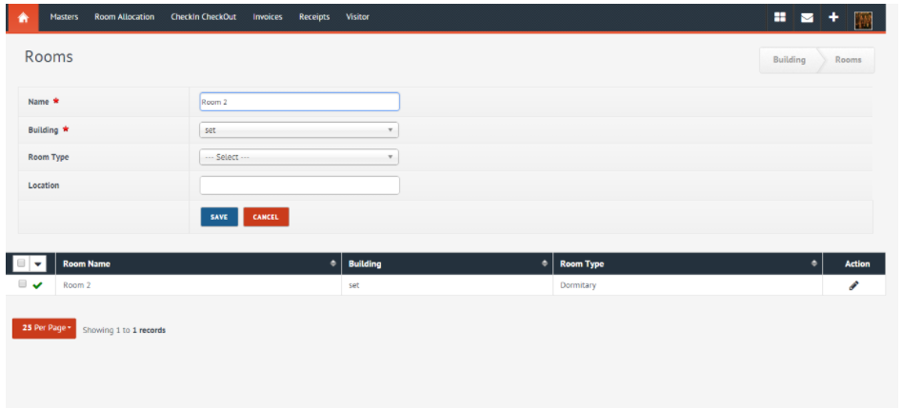

Fig 2.1: College Hostel Management Software by Initio.

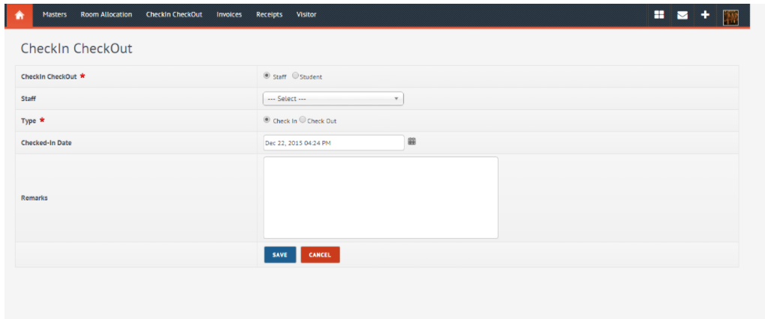

Fig 2.2: College Hostel Management Software by Initio.

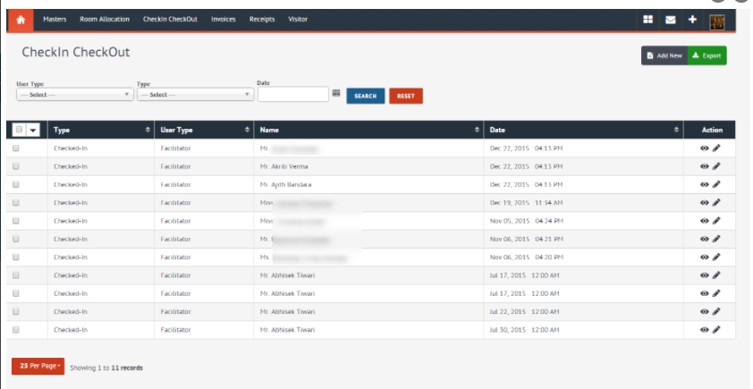

Fig 2.3: College Hostel Management Software by Initio.

## IIUI Hostel

International Islamic University Islamabad Hostel have 15 hostels 8 for male and 7 for Females. Having 2000+ rooms and handle 5000+ students. Automated in 2021 [6]

Fig 2.4: Main page of IIUI Hostel.

Fig 2.5: Sign in page of IIUI Hostel.

* **Students:** For sign in it uses the registration number of students and CNIC number.
* **Admin:** Admin can sign in email/reg no./CNIC and password to sing in into the system.

Fig 2.6: Registration page of IIUI Hostel.

* Boys can apply through new application.
* Can renew his allotment.
* Can change the seat.
* And, can apply for mess.

## City Hostels

CityHostels.pk is the biggest program for students and job owners and for travelers where you can find nearby **hostels**, hotels, guest house, apartments. They have register so many hostels all over Pakistan then it provides allotment to students, job owners and to travelers. [7]

Fig 2.7: Main page of City Hostels.

Fig 2.8: Sign in page of City hostels.

* Use email and password as a credential for sing in.

Fig 2.9: Sign up page of City Hostels.

This give details of hostel, its rooms and applicants that are applying for that.

* **Microbes Hostel System** is another application used for hostel allotment in which applicant are accommodated to rooms which they deserve. In this system everything is synchronized and changing in any component updated to whole system.
* **Loventis Booking System** is Property Management System (PMS).
* **Indocon micro engineers limited** developed the hostel allotment system that offers the customize technology and integrate web booking.

# Chapter 3

# Methodology

The project titled “Hostel allotment system” is comprised of the following three modules

Student Module.

Student in this module can enter the details required for the room allotment. The students need to submit the following details

1 First Name

2 Last Name

3 Registration No

4 CPGA

The above details will be entered by the students.

Hostel Management Details.

In this module of hostel management details, there will be admin, RT, senior warden.

Admin Roles:

The following are the roles which admin has the authority to manage the system.

Admin can make policies for room allotment.

Admin can allot the room.

Admin can check fee defaulter status.

Admin can check mess defaulter status.

Admin can eligibility criteria base on CGPA.

Admin can check the number of available rooms.

Admin can check reserved rooms.

Admin will allot the room to the students if the student is eligible for the room.

The data will be stored to the system which admin can use for processing.

Admin can change the policy.

Room Allotment Module.

This module is managed by admin.

The Diagram of the proposed working mechanism is illustrated below.

Fig 3.1: Proposed working system

## Methodology

Steps of development as well as development tools that will be used in project:

### Development Steps

* We have developed a web application system based on the following front and backend frameworks.
* We have used React.JS for frontend and,
* Bootstrap and CSS for styling.
* We used online template and designed our own.
* We have used Node.JS for the backend.
* We have used MongoDB for Database management.
* Our whole application is based on single computer in initial stages.
* Other than this, we have used networking tools if necessary.

## How it works?

* In the very first step,
* The applicant creates account (Sign up).
* User will be displayed a signup page
* After the signup the user will be displayed.
* Log in into account page.
* Then the user will see a fill the allotment form.
* The user will submit the details.
* First Name, Last Name, Registration No, and CGPA.
* Based on the above details the admin will be able to check the details.
* The details will be stored in Data base.
* The admin has specific roles.
* The RT can assist admin.
* The Senior warden can also assist the admin.
* View the defaulters list.
* View the room allotment list.
* Admin creates account (sign up)
* Provide secret key.
* Log in into account.
* Provide email & password.
* Defines polices.
* Update defaulters
* Allot the rooms.
* Logout from Account.

## Development tools

**Below are the tools that would be used to build the proposed system.**

### React [8]

React.js is a JavaScript open-source library which is used primarily for single-page applications to create user interfaces. It's used by online and smartphone applications to manage the display layer. React also helps one to build UI modules that are reusable. Jordan Walke, a software developer working for Facebook, first developed React. React was first launched on the news feed of Facebook in 2011 and on Instagram.com in 2012.

React helps developers, without reloading the website, to create massive web apps that can alter details. Redact’s primary goal is to be fast, scalable, and simple. This only operates on user interfaces inside the program. In the MVC template, this refers to the view. It can be used with a combination of other frameworks or JavaScript libraries, such as MVC's Angular JS.

Also, React JS is simply called React or React.js.

#### Features:

**JSX** [8]

In React, it uses JSX instead of using a standard JavaScript template. JSX is a basic JavaScript that allows quoting HTML and uses subcomponents to render these HTML tag syntaxes. The HTML syntax is processed into React Framework JavaScript calls. We can write in old, pure JavaScript, too.

#### Single-Way data flow [8]

In Respond, a collection of immutable values in its HTML tags are transferred as properties to the component renderer. The part does not change any properties directly, but with the aid of which we can do modifications, it can transfer a call back function. The "properties flow down; actions flow up" is known as this full method.

#### Virtual Document Object Model

React builds a buffer for the in-memory data structure that computes the modifications made and then updates the browser. This includes a special function that encourages the developer to code as if with each change the entire page is rendered, while the react library only makes components that actually change.

### Node.JS [9] [10]

Currently, Node.js is not a library or framework, but a runtime environment, based on the V8 JavaScript engine of Chrome.

The code was first unveiled at the annual European JSConf back in 2009 by Ryan Dahl and was quickly recognized as "the most stimulating single piece of software in the modern universe of JavaScript."

Node.js was funded by Joyent, a cloud storage capacity and hosting solutions company, as an open-source initiative. The firm has invested in a variety of other revolutions, such as the Ruby on Rails platform, which has supported Twitter and LinkedIn with hosting services. The latter also is one of the first organizations to use Node.js for its backend of smartphone applications. A variety of industry giants, such as Uber, eBay, Walmart, and Netflix, to name a handful, later embraced the technology.

It wasn't until recently, though, that broad recognition of server-side JavaScript with Node.js began. As per Google Developments, interest in this technology topped in 2017, and stays strong.

#### Features:

Both Node.js library APIs are asynchronous, i.e., non-blocking, asynchronous and event driven. It basically indicates that a server build up on Node.js never waits for an API to return outcomes. Later calling it, the server shifts to the next API and a Node.js Events feedback system lets the server get a response from the previous API request.

Node.js library is very fast in code execution as it is installed on Google Chrome's V8 JavaScript Engine.

Single Threaded yet Extremely Elastic, Node.js uses an event-looping single threaded architecture. In comparison to conventional servers that generate small threads to manage requests, the event mechanism allows the server to react in a non-blocking way and renders the server highly scalable. Node.js uses a single threaded program and a significantly greater number of requests can be serviced by the same program than conventional servers like Apache HTTP Server.

No Buffering, applications from Node.js never buffer any data. In chunks, these applications simply output the results.

License − Node.js is published under a license from MIT.

### MongoDB [11]

#### What is MongoDB?

MongoDB is a NoSQL document-oriented database used for data collection in high volumes. MongoDB makes use of lists and records instead of using tables and rows, as in conventional relational databases. Documents consist of key-value pairs in MongoDB that are the fundamental data unit. The collections contain records and feature sets that are like relational database tables. A database that came into light in the mid-2000s is MongoDB.

#### Features: [11]

1. There are collections of each database, which in turn contain records. With a varying number of fields, each text may be different. Each document's size and content can be different from each other.
2. The paper structure is more in line with how developers in their respective programming languages build their classes and objects. Developers would also say that their groups are not rows and columns, but that key-value pairs have a simple structure.
3. The rows (or documents referred to in MongoDB) do not need to have a schema specified in advance. Instead, it is possible to build fields on the fly.
4. Within MongoDB, the data model available enables you to represent hierarchical relationships, store arrays, and other more complex structures more effectively.
5. Scalability-It is very flexible for MongoDB environments. Companies around the world have identified clusters with some of them operating 100+ nodes inside the database with around millions of records.

## Block-Diagram

A block diagram is a system diagram in which the main elements or functions are represented by blocks that are connected by lines that illustrate the relationships between the blocks.

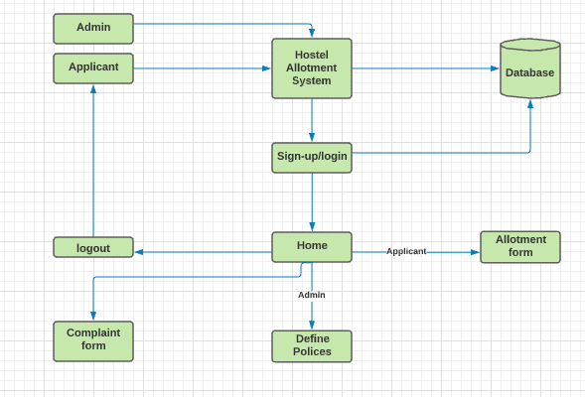

Fig 3.1: Block Diagram of Hostel Allotment System

## Use-case diagram

Use Case Diagram describes the system's functionality and requirements by using actors and use cases. Use Cases design the services, tasks, functions that a system needs to perform. Use cases showing high-level functionalities and how the user will handle them.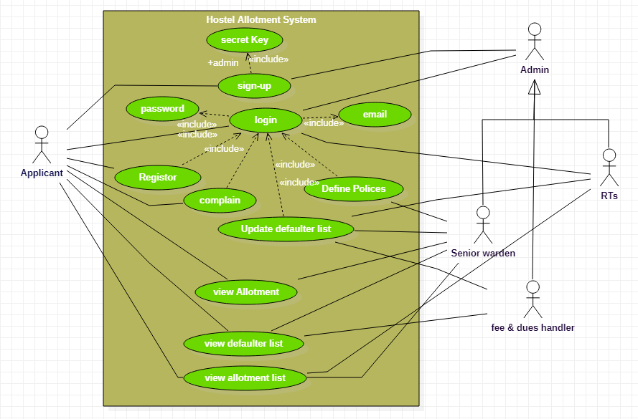

Fig 3.2: Use case diagram of Hostel Allotment System

## Data-Flow Diagram

Data Flow diagram (DFD) represents the visual look of the information flow in a system.

It graphically represents the right amount of requirement of the system.

There are three levels in a Data Flow Diagram 0-level, 1-level, and 2-level.

### 0-level DFD

It is also called as a context diagram. It shows the abstract overview of the system both input and output data through arrows.

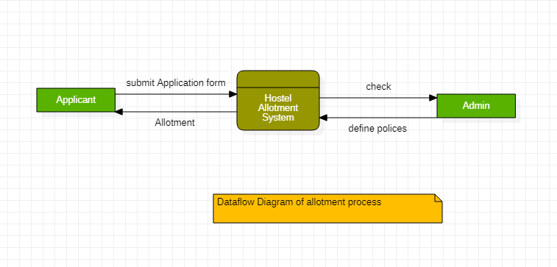

Fig 3.3: 0-level DFD of HAS

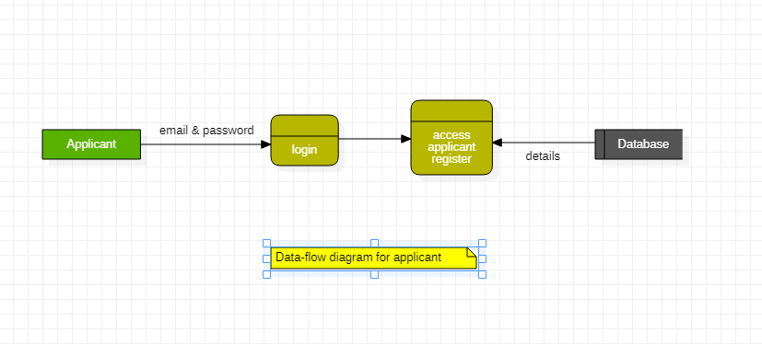

Fig 3.4: 0-level of DFD of HAS

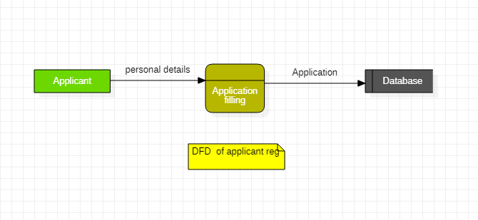

Fig 3.5: 0-leve DFD of HAS

### 1-level DFD

Composed of multiple process, highlight the main functionalities of system and breakdown the 0-level process into subprocess.

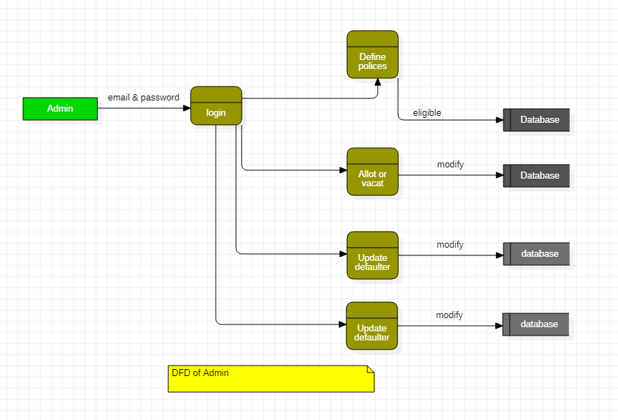

Fig 3.6: 1-level of DFD of HAS

### 2-level DFD

It is one step deeper level of the 1-level. It represents the specific functionalities of the system.

Fig 3.7: 2-level DFD of HAS

## Project Timeline

Table 3.1: Project Time-line of HAS

## Experimental / Simulation Setup

We simulate our system by providing data means defaulter list by uploading an x.ls sheet from our computer on randomly data. And fill some registration forms to check the allotment process of different hostels. Also defines different polices for different department to check the allotment process.

## Details of Work Packages Completed/ Milestones Achieved

### 3.9.1. Requirement specification:

We have gathered information about the hostel allotment process in UET Taxila by analyzing the hostel allotment process of UET Taxila.

### 3.9.2. Designing Phase

We designed our system by drawing the block diagram, use case diagrams, and data flow diagrams.

### 3.9.3. Developing Phase:

We have developed our project by using React.js for the frontend and Bootstrap and CSS for styling them. We use node.js for our backend development and MongoDB for the management of databases in our system.

### 3.9.4. Testing and deployment:

We have test HAS by random data accordingly as per the requirement of the users and it works as per users' requirements.

### 3.9.5. Documentation:

We have completed our thesis and a user manual or using-tutorial will be completed soon.

## Evaluation Parameters

### 3.10.1. Accuracy

The accuracy of the system will be checked on that how accurate it allots the rooms based on the defined policies.

### 3.10.2. Efficiency

That the web application would not take a lot of time in processing that user would become uninterested.

### 3.10.3. Responsiveness

It could be responsive on any system and would show the content according to the screen.

### 3.10.4. Server-Side Processing

The sever will be process the data and stored in the database easily and safely.

# Chapter 4

# Result and Discussion

## Product Demo/ Screen Shots

### Website

The screen shot of the product demo are as follow:

The main page consists of the following.

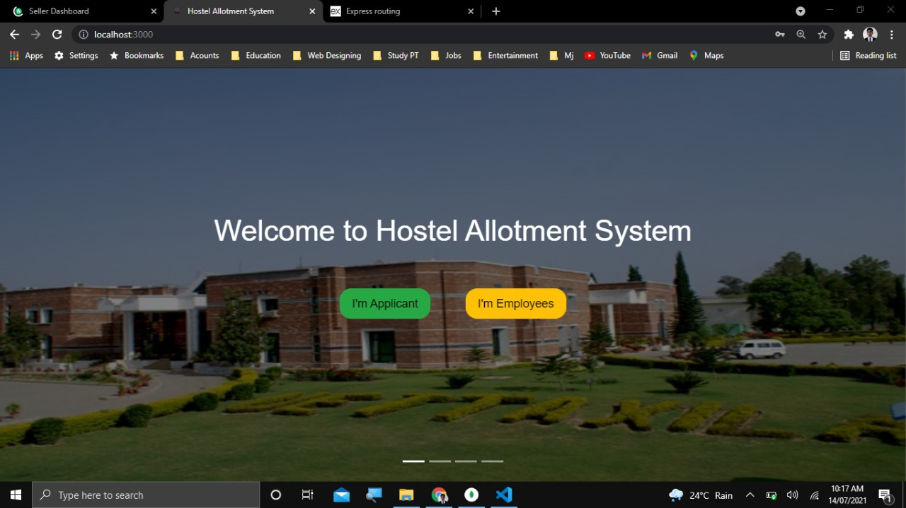

Fig 4.1: Main Page of HAS

Main page of Hostel Allotment system contains two buttons:

* Choose “*I’m Applicant”* button if you are an applicant then related page to applicant will be appeared.
* Choose “*I’m Employees”* button if you are an Employee or admin then related page to employee/admin will be appeared for further process.

Fig 4.2: Home Page of HAS

Fig 4.3: Log in page of HAS

Fig 4.4: Applicant Details of HAS

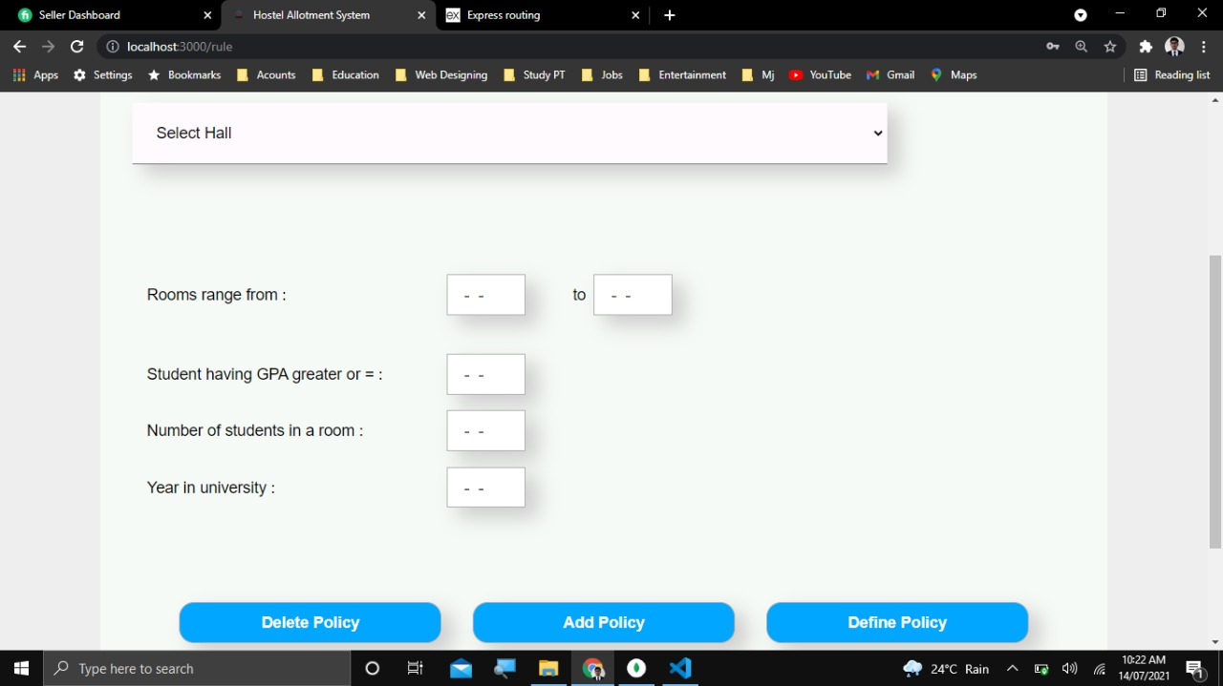

Fig 4.5: Define Polices page of HAS

Fig 4.6: Defaulter’s page of HAS

Fig 4.7: Sign up page of HAS

## Utilization (End Users/ Beneficiaries)

* To summarize the details of our web-based application.
* The main benefits of our web-based application are as under:
* Our project is about a Hostel allotment system can be used in any hostel.
* Any organization or institute that can afford and get benefits from this system.
* This system will provide students an easy way to submit allotment forms and allot room from anywhere.
* It also provides dues & fee information.
* It facilitates the admin that can easily handle all the allotment process from one place.
* It greatly minimizes the manual work.
* It saves a lot of time of students, RT, admin, and wardens.
* It enhances the hostel allotment system.
* It secures the data of all the students.
* It also makes the mundane task.
* It makes the process of updating the entry fast.
* The students can get room within a day.

### The end-users are as follows:

1. Admin & staff (Senior Warden, RTs, dues & scholarships section).
2. Applicants (can be applicant Father, mother, brother, sister etc.).

## Budget Requirements

This project needs a minimum of 1,92,000 details are as following:

Table 4.1: Budget

|  |  |
| --- | --- |
| **System Requirements** | **Budget** |
| Domain | 75,000 |
| Host | 75,000 |
| Deployment of system | 42,000 |

## Market Forecasting

As our project is about the allotment of students so we can target schools, colleges, and universities by contacting them through email and informed them about our project that they can take benefits from our system by explaining all features of the Hostel Allotment system.

If we deployed the app to 10 organizations a year, each for 300,000 RS, then at the end of the year, gross sales will be:

300,000 x 10 = 3,000,000

Revenue

3000,000 – 1920000 = 1080000Rs.

# Chapter 5

# Conclusion

In this work, we developed a web based automated hostel allotment system. The user gives the detail information to the system. This application is specifically designed for the students of UET Taxila and can be used for any other hostel. The system is user- friendly and can be access online. This application is design and developed using the JavaScript framework React.js as front-end with Bootstrap and CSS and Node.js as back-end website development. To maintain data its uses MongoDB as a database.

Our web-based application deals with the problem of managing the problems of students that faces while applying manually. Hostel allotment system is a very useful web-based application this reduces the effort of the hostel managers to manage and keep the record easily and safely. This web-based application has a user-friendly interface with a rich GUI for easy to understand, easy to use. We will add more functionalities and make it more efficient and responsive to expand it to other universities and other private hostels in the future.

## References

[1] [Online]. Available: www.kassoftindia.com/Product/GeniusAcademic/hostelmgt.html. [Accessed 24 September 2012].

[2] [Online]. Available: http://nptel.iitm.ac.in/courses/Webcoursecontents/IIScBANG/System%20Analysis%20and%20Design/pdf/Lecture_Notes/LNm5.pdf . [Accessed 20 June 2012].

[3] E. A. B, "HOSTEL MANAGEMENT SYSTEM," June 2015. [Online]. Available: https://www.academia.edu/37040228/HOSTEL_MANAGEMENT_SYSTEM_full_project_1_.

[4] [Online]. Available: http://www.bbnisys.com/images/eschool.pdf. [Accessed 10 Oct 2012].

[5] [Online]. Available: http://www.educationmanagementsoftware.com. [Accessed 15 June 2011].

[6] IIUI, 2021. [Online]. Available: http://usis.iiu.edu.pk:64453/.

[7] 2017. [Online]. Available: https://www.cityhostels.com.pk/about/.

[8] J. Walke, "React (JavaScript library)," 22 march 2021. [Online]. Available: http://en.wikipedia.org/wiki/React_(JavaScript_library).

[9] R. Dahl, "Node.js," 23 June 2021. [Online]. Available: <https://en.wikipedia.org/wiki/Node.js>.

[10] Khan, A. and Ahmad, S.R., 2012. Desktop GIS application for hostel management of Punjab University Lahore. Journal of Himalayan Earth Science, 45(2).

[11] ZIBRA, A., 2018. The digitization of the Italian hospitality industry: an empirical analysis.

[12] Kumar, A., 2015. Information Seeking Behavior of Faculty Members and Students in the Digital Environment Great Lakes Institute of Management: A Case Study. History, 21(72), pp.285- 294.

[13] Hazen, D., Horrell, J. and Merrill-Oldham, J., 1998. Selecting Research Collections for Digitization.

[14] Intelligent security system for girls in hostel Amol Sapkal1, Samiksha U.Katait2, Puja S. Ingole3, Neha Dumre4, Preeti Ughade IJARSE, Vol. No.4, Special Issue (01), March 2015

[15] Aamir Nizam Ansari, A. Navada, S. Agarwal, S. Patil and B. A. Sonkamble, "Automation of attendance system using RFID, biometrics, GSM Modem with .Net framework," 2011 International Conference on Multimedia Technology, Hangzhou, 2011, pp. 2976- 2979.

[16] Marshall, Esther and Lynette Mackenzie. “Adjustment to residential care: the experience of newly admitted residents to hostel accommodation in Australia.” Australian occupational therapy journal 55 2 (2008): 123-32 .

[17] Sonar, Sneha and Rajendra Patil. “Hostel In Out Management and Monitoring System Using RFID , Face and Thumb Recognition.” (2016).

[18] Ayanlowo, Kola, et al. "Development of an Automated Hostel Facility Management System." Journal of Science and Engineering 5.1 (2014): 01-10.

[19] Sabeha, K., and P. Sukumar. "Highly Secured Indoor Outdoor Localization forE-Hostel Management." Journal of Network Communications and Emerging Technologies (JNCET) 5.1 (2015): 30-34.

[20] Wollnik, H., Haas, R. and Kassen, F., Carl Zeiss AG, 1984. Process for the digitization and display of thermographic records. U.S. Patent 4,445,516

[21] Marshall, E. and Mackenzie, L., 2008. Adjustment to residential care: The experience of newly admitted residents to hostel accommodation in Australia. Australian Occupational Therapy Journal,55(2)

[22] Zaini, H., 2005. Online Hostel Mawar application (Doctoral dissertation, Faculty of Information Technology and Quantitative Sciences).

[23] GOUD, D., 2014. Hostel facilities for tribal students.

[24] Ajibola, A.S., 2013. Studies of heuristics for hostel space allocation problem (Doctoral dissertation).